**E-mail proposal for Joyner Bolt**

We should like to take this opportunity to present to you a revolutionary new engineered timber fixing – The Joyner Bolt.

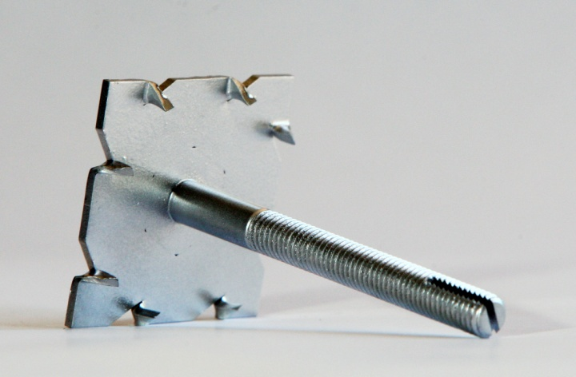**Sample M8 – 115mm long Joyner Bolt.**

The Joyner Bolt has been borne out of the frustrations experienced by the co-inventors – Mark Doye and Daniel Hardingham - in using the traditional methods of fixing timber to timber or to third party materials.

Presently, to secure a timber member to a third party material involves drilling a hole through each material where they should be joined. There are then two traditional methods of securing the materials together:

**Option 1 – A ‘Coach bolt’** is passed through the hole, a nut and washer is then tighten onto the threaded end.

The use of a ‘coach bolt’ in securing timber members has many drawbacks and limitations, namely:

1. It relies on the contractor to drill the correctly sized hole through the timber members. Due to the small head size in relation to the wire size, there is little tolerance for drilling an over-sized hole.
2. Due to the small surface area of the head to the coach bolt, it is usual for Building Control Officers to request the use of a 50mm x 50mm washer.
3. It is a common occurrence for the coach bolt to turn within the timber before it is completely tight or reached the correct torque.
4. It is also a common occurrence for the small head to be pulled into the timber member, deforming the timber face, thereby reducing the effective structural depth of the timber as designed.
5. The domed head to the ‘coach bolt’ makes it difficult to then fix finishing materials, such a plywood and plasterboard as it is not possible to achieve a true level surface without remedial works being required.
6. There are instances which require the contractor to pass the ‘coach bolt’ through the first member and then offer up the second member over the ‘coach bolt’. As we all know, invariably the second member pushes the ‘coach bolt’ out of the first member adding to the frustration.
7. Due to the small surface area of the head to the ‘coach bolt’, it is difficult to achieve the correct torque to the nut without deforming the surface of the timber member. This is a particular issue when the head of the bolt is visible. It leads to an unsightly finish.
8. There is no facility to restrain the bolt in position.

**Option 2 - A threaded rod** is cut to the correct length to fit through the hole created, with a small excess on either side. A washer and a nut are tightened onto each end, holding the pieces of timber together.

The use of threaded rod in securing timber members also has many drawbacks and limitations, namely:

1. Wastage is excessive and common due to the bars being supplied in set lengths. It is exceptionally unusual to use the entire rod.
2. When the rod has been cut, the thread becomes deformed making it difficult to thread the nuts.
3. In order to fix the rod in position, it requires two sets of nuts and two sets 50mm x 50mm washers, which is extra expense.
4. It is a common occurrence that when you are tightening one nut, the bar has a tendency to turn within the opposing nut, thereby winding the rod through the timber members.
5. There is no facility to restrain the nut or threaded rod in position.
6. It is an awkward and time-consuming activity for those working in construction, as they must tighten one washer and nut onto one side of the threaded rod, then hold it in place with a spanner whilst tightening a washer and nut on the other side resulting in continuous access being required to both sides of the bar, using two separate spanners, in order to secure the fixing. Space constraints commonly experienced on construction sites often restrict the possibility of achieving this.
7. The nuts can become loose and may be lost, decreasing the likelihood of the fabrication staying together and potentially putting people at risk.

The Joyner Bolt is designed to improve the time, speed and quality of grip when joining two pieces of timber together or to any other material.

It is aimed at the construction industry for which it will provide the following practical benefits over the current bolts in use:

1. **No European BANNED hexavalent chrome used in any plating.** **Min 9.3 microns plating.**
2. All bolts made to Min ISO898-1 Grade 4.8 (Other Grades available on request).
3. It is easy to use as it requires fewer individual parts to secure the timber pieces.
4. Requires only one tool to secure the fixing in position.
5. Once tightened, it cannot easily loosen and fall out of position, thus providing a more secure and long lasting joint.
6. It will not turn during the tightening process, providing a firmer and longer lasting grip.
7. It will not ‘pull through’ the timber.
8. It automatically conforms to building regulations requirements due to surface area of head.
9. The BZP conforms to European Law and is 3 times thicker than BZP from the Far East, thereby affording enhanced corrosion resistance.

**We believe that the ‘Joyner Bolt’ will become the**

**method of choice to connect timber members together.**

**Brief Summary of the Product**

It can be seen by the above that a need has arisen for a means of securing pieces of timber together that does not require many separate parts, is easy to install and cannot simply loosen and fall out of position. It is therefore an object of the ‘Joyner Bolt’ to provide a device achieving this.

To this end, the ‘Joyner Bolt’ comprises: a bolt head with a series of spiked teeth on its underside; a cylindrical bolt rod extending from the bolt head comprising a thread and a split end, forming a slot.

The user drills a hole through the pieces of material to be secured together, and hammers the bolt through the hole. The spiked teeth on the bolt head lock into the timber, securing the bolt on one end. At the free, split end of the bolt, a washer and nut are tightened onto the bolt. A cold chisel is hammered into the slot between the split ends of the rod, bending the ends outwards and thus preventing the nut from loosening.

We should welcome the opportunity of discussing our new product with you in greater detail. **Please call Daniel Hardingham – Managing Director, Joyner Bolt on 07775 504904** to arrange a mutually convenient date and time.

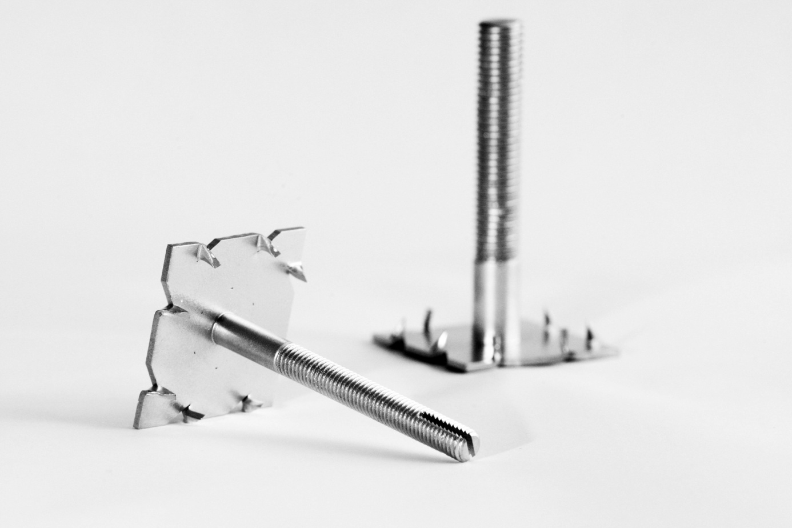

**Joyner Bolt (UK) Limited trading as Joyner Bolt.**

**Registered in England & Wales No. 07405535**

**Registered Office: Kitchener House, Chapel Lane, Wicken, Cambridgeshire. CB7 5XZ**

**VAT Registration No. 119 7793 71**