
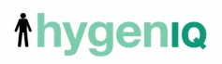

News Release

Armitage Shanks cleans up the public bathroom with hygienIQ
HULL, UNITED KINGDOM – Today, Armitage Shanks, one of UK’s largest manufacturers of sanitaryware, has announced a breakthrough in urinal technology designed to eliminate splash back with the launch of its hygenIQ urinal.
The new urinal has been designed to reduce splash back by 90% thus significantly cutting down associated bacterial growth and washroom surface damage.
Millions of germs find a home in the splashed urine around the urinal and a washroom floor can carry up to 462 bacteria per square inch. In the modern washroom, that is simply too unhygienic to be acceptable.
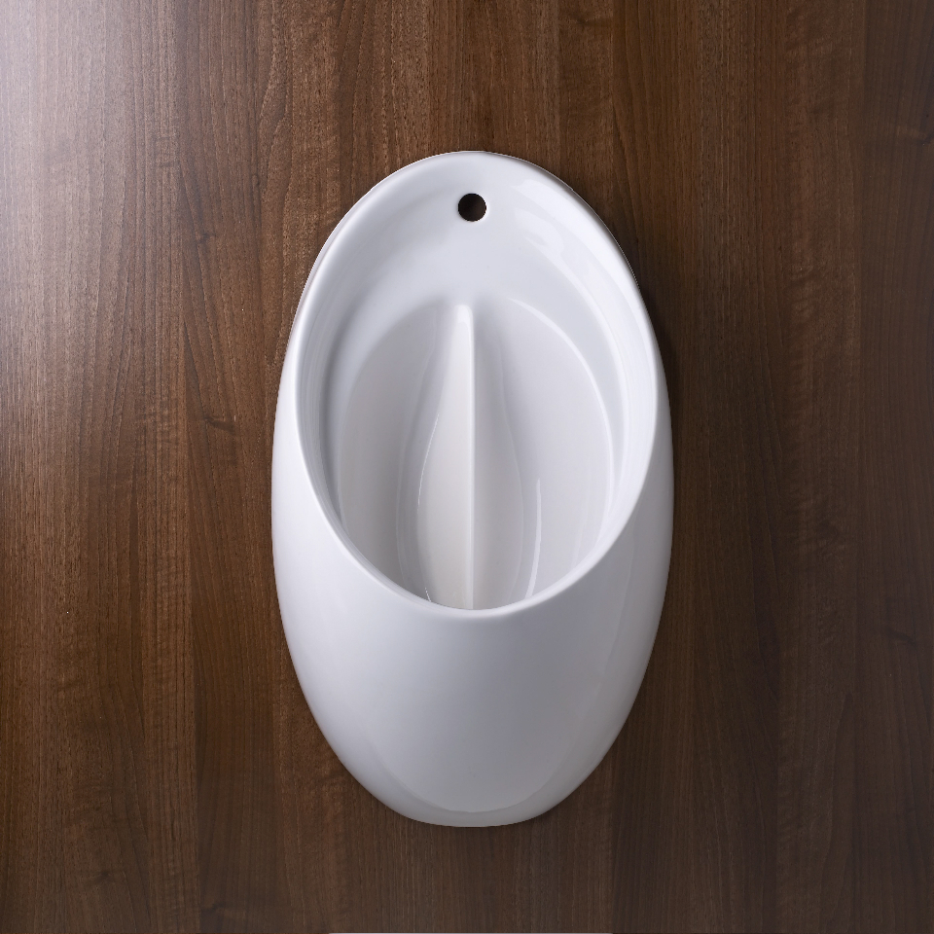
Using principles of advanced fluid dynamics, the new hygenIQ urinal has a central fin cast within the bowl itself. Standing in front of the urinal the user’s flow will hit either side of the fin at a very shallow angle. There will be little or no splashing because at such an angle, surface tension will cause the fluid to cling to the inner side of the urinal bowl. Any splashing that does occur will remain in the bowl itself.
hygenIQ urinals have been subject to rigorous testing alongside traditional urinals. Results were visually captured under ultra-violet light conditions and revealed that traditional urinals create considerable splash back to the surrounding area. Further independent testing in association with the University of Hull proved that the new hygienIQ urinal reduces splash back by up to 90% compared to traditional urinals.

“Every time a urinal is used, no matter how hard a man tries to avoid it, you get a certain amount of splash back. It’s not just messy and unpleasant for users and cleaners but over time urine stains and corrodes wall as well as floor finishes, resulting in increased cleaning and maintenance. With the launch of the new hygenIQ urinal, splash back will be an inconvenience of the past,” said Tony Rheinberg, Marketing Manager at Armitage Shanks.
In places like hospitals, where infection control is a major issue, splashed urine can even present a significant risk to health. Research now proves that cleanliness and hygiene are the number one concern for today’s consumer. Leading biomedical scientist Dr Ron Cutler also recognizes the benefits that the hygenIQ urinal will bring to the public washroom: “The hygenIQ will help minimize the contamination of surfaces by urine and will reduce the potential for any contaminated urine to act as a source of infection. This new urinal technology will form a vital part of the future public washroom.”
The hygenIQ inlets, outlets and fixing points match their standard contour so whether installing from new or retrofitting, this revolutionary new urinal comes in two sizes and is quick and simple to install. It can easily be retrofitted with minimal disruption to the decorative finishes of public washrooms walls. The hygenIQ combines an important functional requirement with a new contemporary look to add aesthetic value to any washroom.
To view the video of hygenIQ please click here:

http://www.hygeniq.co.uk/

For more information or imagery please contact:

The Ideal Standard Press Office

Hill & Knowlton Tel: 0207 413 3242

Email: idealstandard@hillandknowlton.com

About Armitage Shanks:
The company that became Armitage Shanks was founded in 1817 by Thomas Bond in Armitage, Staffordshire. The Armitage "sanitary pottery manufacture" became a successful UK toilet manucturer. In 1969 Armitage merged with Shanks Holdings Limited, a competing "sanitary engineering company" established at Barrhead near Glasgow, Scotland in 1878, producing the famous brand name Armitage Shanks. In February 1999 Armitage Shanks became part of the American Standard group of companies.

Research conducted by Engine

