News Release | June 2017

Market Leader Armitage Shanks digs deeper in fight against hospital infections
Launching their most advanced healthcare solutions yet

- Iconic British manufacturer, at the forefront of Healthcare innovation, launches a new hospital solution designed to help reduce the opportunity for bacteria growth in basins, taps and WC’s
- Unique to Armitage Shanks ‘Hydrofin’ cuts infection risk by reducing splashing from basins by over 90%
- Advanced maintenance procedures provide an ongoing tool kit to continually fight bacteria
- Solutions that are used in clinical areas are now available to be used in all areas of hospitals

Armitage Shanks, the leading British commercial bathroom, sanitaryware and washroom installations provider, has been working in partnership with leading scientists and specialists to develop two new innovative healthcare solutions, helping the fight against infection in hospitals.

The new Markwik 21+ fittings and Contour 21+ clinical ceramics ranges have been developed in response to the evolving threats in hospitals and significantly push forward hygiene innovation and bacterial prevention. The range provides a complete solution, helping to reduce the opportunity for bacteria to grow throughout hospitals

It comes as the International Scientific Forum on Home Hygiene (IFH) confirms that areas featuring sanitaryware are virulent breeding grounds for bacteria and viruses.

Furthermore, a report by the UK’s House of Commons on ‘Reducing Healthcare Associated Infection (HAI) in Hospitals in England’, found that annually 300,000 people contract a HAI after a hospital visit, creating a £1 billion additional care cost for the NHS.

It also advises that appropriate sanitary precautions can actively prevent the spreading of dangerous germs.

Markwik 21+ and Contour 21+ achieve this by addressing pooling and water stagnation, reducing splashing and the amount of static water in the system, working with materials that limit the opportunity for bacteria to feed and providing a flexible maintenance system for cleansing fixtures and fittings.

The launch of the innovative new healthcare ranges comes as Armitage Shanks celebrates its 200-year anniversary this year.

CONTOUR 21+: INNOVATE CERAMICS WITH SPLASH- REDUCING TECHNOLOGY
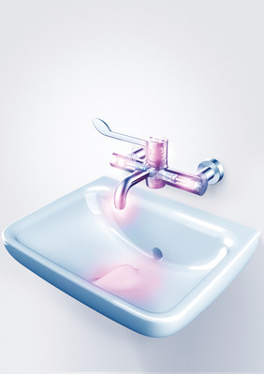
Research shows a high level of splashing occurs when taps run into clinical basins, spreading bacteria and viruses into the air, onto the face, clothing and the surrounding area, such as hospital beds. This splashing and spreading of germs can reach over a metre in distance. Armitage Shanks has designed HydroFin—an innovative fin to the base of the Contour 21+, which deflects splashing and reduces it by over 90 per cent.

The Contour 21+ range includes integral SmartGuard antimicrobial additive technology. This effective antimicrobial protection reduces the threat of cross-contamination and helps keep surfaces clean and hygienic across their lifetime. Further, the ultra-smooth glaze of Countour21+’s SmartGuard+ has been designed to make it more difficult for bacteria to cling to the surface.

Water pooling in basin wastes is a prevalent source of bacterial growth and a common problem in clinical, back-outlet basins. The Contour 21+ basin features advanced drainage to combat this. Its simple waste assembly ensures water drains instantly and vertically, through a smooth pipe system, free of steps or hanging points. Contour 21+’s outer surfaces feature thinner, more angular rims, steeper slopes and a smaller back area—all designed to avoid water pooling and facilitate easy cleaning.

MARKWIK 21+: ADVANCED HEALTHCARE FITTINGS

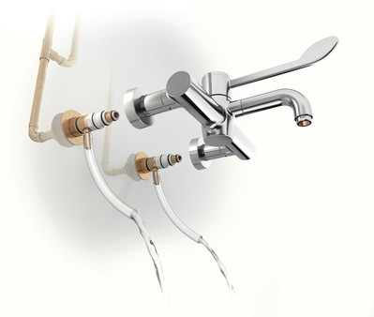
Mixer taps have been identified as a potential risk area where bacteria can grow. Pseudomonas Aeruginosa present a particular threat up to 2 metres back from the outlet. Legionella can grow where water stagnates in pipes and fittings.

Markwik 21+ has been developed following extensive research into where and how bacteria grows. Care has been taken into reducing materials that bacteria can feed on, reducing the amount of water left in taps after use and more options to cleanse fittings either by thermal cleanse procedures or the complete dismantling of fittings for disinfection.

Markwik 21+ is almost entirely free of polymers, and contains glass, brass and antimicrobial copper components, minimizing the likelihood of Pseudomonas infection and other growths. The new range is over 85% brass and reduces polymer content by 66%. Waterways are reduced in size reducing the amount of water left in tap by 34%.

A manual thermal flush feature allows maintenance staff to override the thermostat and flush the fitting through with hot water to help reduce bacteria deposits, maximizing the antimicrobial effect. An integral thermostat enables water to be mixed closer to the point of discharge – eliminating the cold water ‘dead leg’ and minimizing warm water areas, both of which can harbour germs.

Markwik 21+’s auto-flush technology ensures irregularly used electronic fittings are flushed through with water every 24 hours, preventing the formation of bacteria. A ‘hydro-purge’ facility flushes water through the pipework and inlets to ensure a debris free system after installation and enables flushing after chemical disinfection. Detachable spouts, one piece designs and demountable body components allow for complete immersion disinfection and autoclaving.

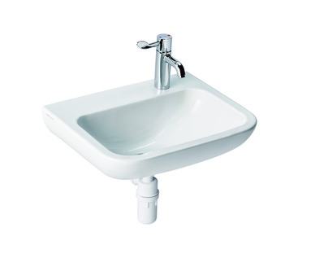
FIRST TO THE MARKET - CLINICAL BASIN DESIGNED FOR USE IN PATIENT AREAS

Currently hospitals tend to use bottom outlet basins with deck taps. This type of basin can pose a threat to patients with weak immune systems as bacteria growing in wastes can be released when water flows directly down the drain.

The new Contour 21+ deck basin comes with back outlet and a special clinical tap that can be easily detached from the basin, dismantled and disinfected. This is the first basin and tap of its kind and is a major advance in bringing clinical solutions across all areas of the hospital.

BASIN INSTALLATION REDUCED TO 7 MINUTES

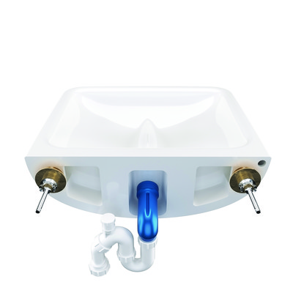
The easy and flexible installation options of the new Markwik 21+ and Contour 21+ ranges makes them simple to install. Contour 21+ can even be installed by one person in 7 minutes compared to its predecessor which took 2 people 18 minutes, saving installer’s time and reducing the cost for specifiers.

All Markwik 21+ taps are fully compatible with Pall Medical sterilising water filters, adding an extra barrier against infection. The Markwik 21+ and Contour 21+ ranges fit seamlessly together, providing a fully integrated tap and basin system that offers the optimum in clinical hygiene.

Tony Rheinberg, from Armitage Shanks, comments: “Armitage Shanks has a well-earned reputation, especially in the field of healthcare and infection control.

“The new Contour 21+ and Markwik 21+ ranges demonstrate our innovation based approach, which is built on 200 years of experience and continues to pushes forward with healthcare innovation, aiding the battle in the fight against infection.

“We have taken a scientific approach, working with a host of leading NHS trust partners and researchers in order to bring new clinical solutions to all areas of the hospital.

“Often some of the most simple of issues can be the most difficult to solve – and that’s what makes our new hydrofin design so ground-breaking, as it reduces the recognised major risks of spreading infection caused by splashing water from a tap in a basin.”

-ENDS-

For more information, visit www.idealstandard.com or contact:
The Ideal Standard team at Havas PR UK
T: 0161 236 22 77
E: idealstandardpr@havas.com

About Ideal Standard International
Ideal Standard International is one of the world’s leading manufacturers of high-quality residential, commercial and healthcare bathroom solutions. Headquartered in Brussels, Belgium, the privately-owned company employs almost 9,500 people and operates 18 manufacturing sites, serving over 60 countries across Europe, the Middle East and Africa. Using the latest technologies and working with world class designers, the company is focused on developing innovative bathroom solutions across multiple product categories including bathroom Ceramics, Taps & Fittings, Bathing & Wellness and Furniture & Accessories. Its products are sold under strong international and local brands such as Ideal Standard, Armitage Shanks (UK), Porcher (France), Ceramica Dolomite (Italy) and Vidima (Eastern Europe).

